**Images of Pixels Plotted (Low Res Version)**

Below, plotted images in order of increasing wavelength. The **purple dots** plotted show successful, perfect fits. The **red dot** is the original pixel I tested where I could not make a perfect fit. NOTE I CAN fit pixels *next to* (1 pixel to right / left) of that red dot.

Hα: 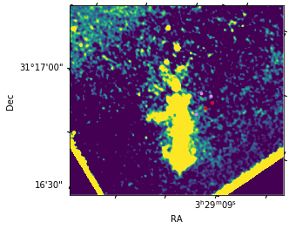

1.26: 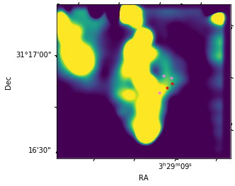

1.28: 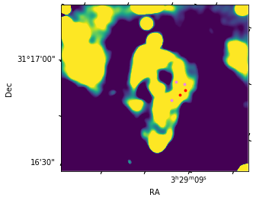

1.64: 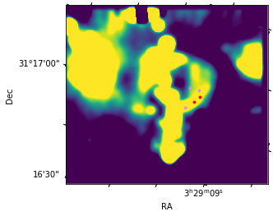

**Blackbody Fits**

Fitting the blackbody fits

Repeat labeling the regions by number for reference:

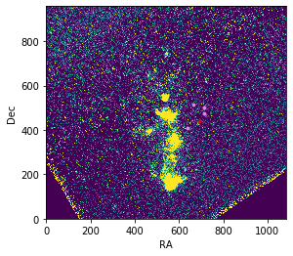

1

2

3

4

5

Table of fit properties:

|  |  |  |
| --- | --- | --- |
| Region # | T (K) | C |
| 1 | 4.22665159e+03 | 3.84083139e-24 |
| 2 | 4.86677015e+03 | 2.76021283e-24 |
| 3 (translated by ~10 pixels) | 3.98825501e+03 | 4.92417700e-24 |
| 4 | 3.53841232e+03 | 1.04686128e-23 |
| 4 (1 pix right, up) | 3.30548984e+03 | 1.30580212e-23 |
| 4 (1 pix left, up) | 3.53650031e+03 | 1.05870783e-23 |
| 5 | 3.49020915e+03 | 1.62986161e-23 |

Blackbody plots (same order as table):

1…

2…

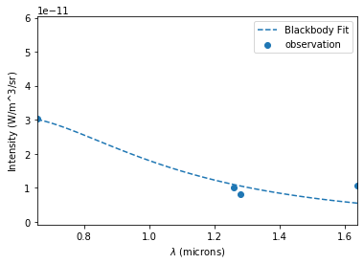

3 (translated by ~10 pixels)…

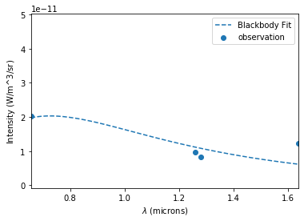

4…

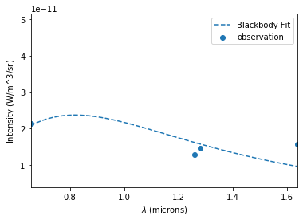

4, 1 pix up, right…

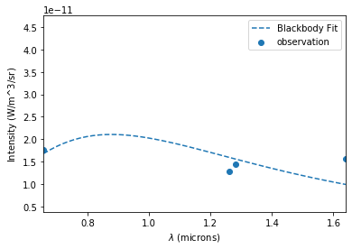

4, 1 pix left, up…

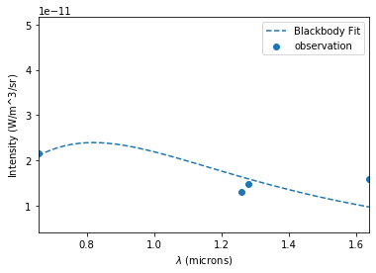

5…

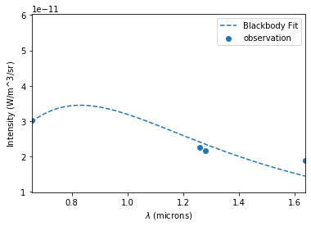

**Fitting Non-Lin Equs for Multiple Pixels**

For each pixel, I *fit by scipy curve_fit*. Newton-krylov will converge to a similar but slightly more accurate value from my tests on the one pixel that didn’t fit, but it is slower to do that, so I’m doing this for efficiency. I consider a fit with the sum of squares is ~1E-40 to 1E-50 (and I can’t distinguish the points on the plot):

|  |  |  |  |  |  |
| --- | --- | --- | --- | --- | --- |
| Fit Parameter | C | AV | fH | fFe | Σ(squares) |
| 1 | -9.65205874e-23 | 7.26112622 | 3.10011544e-10 | 1.61573835e-10 | 1.4877694187036636e-52 |
| 2 | -1.35997859e-22 | 7.52004487 | 5.71909187e-10 | 3.04913205e-10 | 2.6101217871994098e-52 |
| 3 (translated by ~10 pixels) | -2.07148034e-23 | 5.57799835 | 7.93393759e-11 | 4.89424799e-11 | 1.421689401379141e-23 |
| 4 | 3.41909839e-25 | 5.01542549 | 5.18173634e-11 | 2.79501533e-11 | 1.730053192856374e-23 |
| 4 (1 pix right, up) | 9.50779921e-24 | 4.97186772 | 4.00451582e-11 | 2.13512009e-11 | 1.4103174465905054e-23 |
| 4 (1 pix left, up) | 4.02946564e-25 | 5.01415714 | 5.21745998e-11 | 2.81530317e-11 | 1.6848875386904056e-23 |
| 5 | 1.85699331e-24 | 4.97951689 | 7.20282463e-11 | 3.98704756e-11 | 2.23157158180894e-25 |

Intensity Plots of Fits (same order):

1…

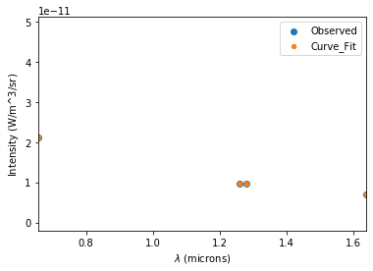

2…

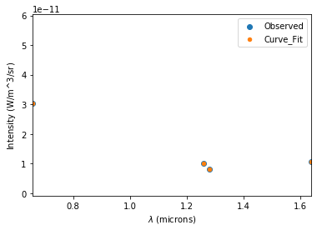

3 (translated by ~10 pixels)…

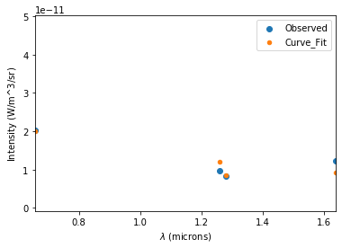

4…

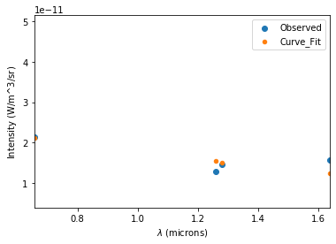

4, 1 pix right, up…

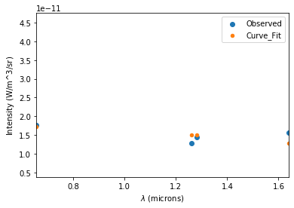

4, 1 pix left, up…

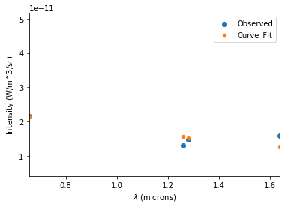

5…

